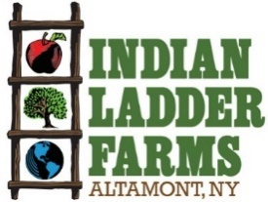

Server Job Description
Indian Ladder Farms is a 325-acre working farm and agritourism destination located in Altamont NY. The farm grows apples, berries, pumpkins and operates an extensive pick your own in the summer and fall as well as presses its own cider. The farm is home to a cidery and brewery, manufacturing and serving hard cider and beer with ingredients grown on the farm. Indian Ladder has an extensive farm market and bakery featuring popular items such as cider doughnuts. Indian Ladder operates two (soon to be three) kitchens, conducting farm to table foodservice in a café, tasting room & biergarten as well as catering private events on the farm. New this year will be a wood-fired pizza oven serving pizza at a third location adjacent to the new brewery.
Position: Server part time/full time/seasonal
Compensation: hourly wage commensurate with experience
Benefits: sick pay, employee discount
Job Requirements
- Professional, respectful and positive demeanor
- Fun-loving, kind and energetic
- High Stamina
- Ability to function as a team player maintaining clear lines of communication with employees and managers across departments farm wide.

Server Responsibilities
- Staying informed about on-site brewery and changing menu items
- Delivering a memorable dining experience by catering to customers individual needs
- Assisting bussers with the tidying of tables, clearing leftovers, and keeping dining area neat
- Collaborating with kitchen and bar staff for prompt and correct delivery of orders
- Multi-tasking, serving multiple tables at once
- Familiarizing self with POS system
- Light side work; stocking, cleaning, closing cash drawers

To apply send Cover Letter & Resume to: donnamerrill@indianladderfarms.com
(Please Specify Job You Are Applying For)
342 Altamont Rd., Altamont, NY 12009
www.indianladderfarms.com

