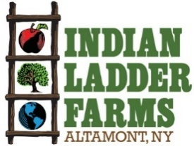
Doughnut Maker Job Description
Indian Ladder Farms is a 325-acre working farm and agritourism destination located in Altamont NY. The farm grows apples, berries, pumpkins and operates an extensive pick your own in the summer and fall as well as presses its own cider. The farm is home to a cidery and brewery, manufacturing and serving hard cider and beer with ingredients grown on the farm. Indian Ladder has an extensive farm market and bakery featuring popular items such as cider doughnuts. Indian Ladder operates two (soon to be three) kitchens, conducting farm to table foodservice in a café, tasting room & biergarten as well as catering private events on the farm. New this year will be a wood-fired pizza oven serving pizza at a third location adjacent to the new brewery.
Position: Doughnut Maker part time/full time/seasonal
Compensation: hourly wage commensurate with experience
Benefits: sick pay, employee discount
Job Requirements
- Professional, respectful and positive demeanor
- Basic Measurement Skills for Baking
- Organization Skills
- Strong Communication Skills
- Working Holidays is Mandatory

Donut Maker Responsibilities
- Organization and maintenance of bakery supplies/ingredients in attic, yellow rock, dry storage, 4 door and main cooler
- Expected to help maintain organization & cleanliness of yellow rock kitchen-not limited to bakers section
- Proper rotation of items to maintain freshness
- Maintenance and deep cleaning of donut machine, bakery equipment, ovens, mixers, tools, coolers and freezers
- Expected to support donut machine as needed-may include coverage of breaks and or/donut bakers days off
- May include dishwashing of equipment, utensils and smallware’s

To apply send Cover Letter & Resume to: chefluca@indianladderfarms.com
(Please Specify Job You Are Applying For)
342 Altamont Rd., Altamont, NY 12009
www.indianladderfarms.com

