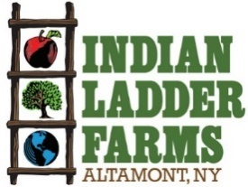

Baker Job Description
Indian Ladder Farms is a 325-acre working farm and agritourism destination located in Altamont NY. The farm grows apples, berries, pumpkins and operates an extensive pick your own in the summer and fall as well as presses its own cider. The farm is home to a cidery and brewery, manufacturing and serving hard cider and beer with ingredients grown on the farm. Indian Ladder has an extensive farm market and bakery featuring popular items such as cider doughnuts. Indian Ladder operates two (soon to be three) kitchens, conducting farm to table foodservice in a café, tasting room & biergarten as well as catering private events on the farm. New this year will be a wood-fired pizza oven serving pizza at a third location adjacent to the new brewery.
Position: Baker part time/full time/seasonal
Compensation: hourly wage commensurate with experience
Benefits: sick pay, employee discount
Job Requirements
- Professional, respectful and positive demeanor
- Basic Measurement Skills for Baking
- Organizational Skills
- Ability to function as a team player maintaining clear lines of communication with employees and managers across departments farm wide.
Baker Responsibilities
- Manage inventory levels of finished baked goods, ingredients, and supplies
- Maintain organization and cleanliness of storage of bakery supplies/ingredients
- Utilize pre-made batters and mixes
- Produce baked goods from scratch
- Work with Chef to calculate cost of goods and retail pricing of baked goods
- Develop of new/exciting bakery items to engage customer and increase sales
- Conduct maintenance and deep cleaning of bakery equipment including ovens, mixers, tools, coolers and freezers
- Provide supplemental support for cider doughnut production as needed
- Provide support to dishwashers as needed to wash equipment, utensils and small wares

To apply send Cover Letter & Resume to: chefluca@indianladderfarms.com
(Please Specify Job You Are Applying For)
342 Altamont Rd., Altamont, NY 12009
www.indianladderfarms.com

