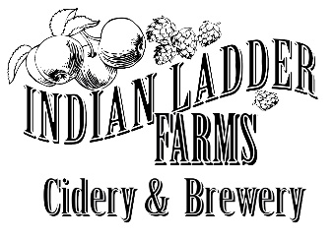

Friday Ramen
Served Every Friday in the Biergarten
4 to 7

FARM-TO-TABLE RAMEN
Farm-made locally sourced meat broth brimming with pork, caramelized onions, sweet pickled radishes, farm-fresh egg, seasonal vegetables, and fresh Ramen noodles
$16

FARM-TO-TABLE GLUTEN-FREE VEGAN RAMEN
Farm-made vegan broth loaded with carrots, broccoli, red onion, bell peppers,
our own vegan kimchi, tofu, and rice noodles
$16

Local Ingredients Sourced From
Highland Hollow Farms—Schoharie, Black Horse Farms--Athens,
Green Acres Community Farms—Amsterdam, Schoharie Valley Farms-Schoharie

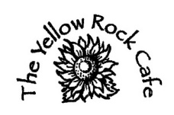
Indian Ladder Farms
342 Altamont Rd.
Altamont, NY

